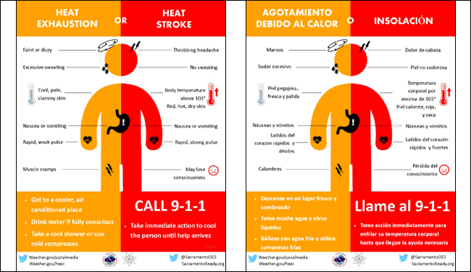

During extremely hot and humid weather, your body's ability to cool itself is challenged. When the body heats too rapidly to cool itself properly, or when too much fluid or salt is lost through dehydration or sweating, body temperature rises and you or someone you care about may experience a heat-related illness. It is important to know the symptoms of excessive heat exposure and the appropriate responses. The Centers for Disease Control and Prevention provides a list of warning signs and symptoms of heat illness, and recommended first aid steps. Some of these symptoms and steps are listed below.

–Heat Exhaustion Symptoms:
- Heavy sweating
Weakness
Cool, pale, clammy skin
Fast, weak pulse
Possible muscle cramps
Dizziness
Nausea or vomiting
Fainting
-First Aid:
- Move person to a cooler environment
Lay person down and loosen clothing
Apply cool, wet cloths to as much of the body as possible
Fan or move victim to air conditioned room
Offer sips of water
If person vomits more than once, seek immediate medical attention.

–Heat Stroke Symptoms:

- Altered mental state
- One or more of the following symptons: throbbing headache, confusion, nausea, dizziness, shallow breathing
- Body temperature above 103°F
- Hot, red, dry or moist skin
- Rapid and strong pulse
- Faints, loses consciousness
-First Aid:
- Heat stroke is a severe medical emergency. Call 911 or get the victim to a hospital immediately. Delay can be fatal.
- Move the victim to a cooler, preferably air-conditioned, environment.
- Reduce body temperature with cool cloths or bath.
- Use fan if heat index temperatures are below the high 90s. A fan can make you hotter at higher temperatures.
- Do NOT give fluids.
North American summers are hot. Sometimes spring and fall temperatures reach dangerous levels as well. Most summers see heat waves in one or more parts of the United States. Heat is one of the leading weather-related killers in the United States, resulting in hundreds of fatalities each year and even more heat-related illnesses.
More information can be found at:
https://www.weather.gov/safety/heat

